Table of Contents
Brief Introduction ---------------------------------------------------------- 2
Installation and Connection --------------------------------------------- 3
System Programming ----------------------------------------------------- 4
Precaution ------------------------------------------------------------------- 4
Ringing Extension Assignment ----------------------------------------- 4
Prefix Digits Restriction and Special Dialing number -------------- 4 Outward Calling Class Assignment ----------------------------------- 5
Call Duration Restricted -------------------------------------------------- 6
Caller I D Assignment ---------------------------------------------------- 7
Restore the Default mode ----------------------------------------------- 7
Operating Instruction: ---------------------------------------------------- 8
Answer the Call ------------------------------------------------------------ 8
Outward Calling --------------------- -------------------------------------- 8
Intercom Communication ------------------------------------------------ 8
Call Transferring and Three Way Conference ---------------------- 8
Make Outgoing Call by Assistant -------------------------------------- 9
Call Pick U p --------------------------------------------------------------- 9
C.0 line Appointment ------------------------------------------------------9
Operating Instruction
2. Installation
Outward Calling: Dial the C.O line number directly
Call Transferring: Dial * before the Extension number. Intercom Communication: Dial * before the Extension number.
2.1 This model adopt plastic material with curve, there has two small holes at the back of unit for hang the unit on the wall purpose. The LED can show the actual working state of CPU and Extensions. The LED of Power will flash when the power is connected that indicate the working is normal.
1 Brief Introduction
Thank you for purchasing our Telephone Switch; please read this manual to learn its powerful features and easy operating.
This model has double communication path, support DTMF / FSK mode for caller ID, maximum has one C.O line and Eight Extensions; you can use telephone, fax machine, voice recorder and computer as Extensions.All the Data will not be lose even in the power failure, and Extension No.1 can keep working.
This system can supply various indicating tone, such like: Dial Tone; Ringing Tone; Error Tone; Busy Tone and Confirm Tone.
2.2 This unit should be kept free of dust, moisture, high temperature (more than 40°C { 104F )) and vibration, and should not be exposed to direct sunlight.
2.3 Please insert the C. O line to the jack of LINE, jack 1~8 for Extensions, and the unit can be used after power is connected. Do not wire the telephone cable in parallel with an AC power source, computer, telex, etc. The power supply should be 220V, please insure the connection is under good condition, otherwise will cause noise or disrupted.
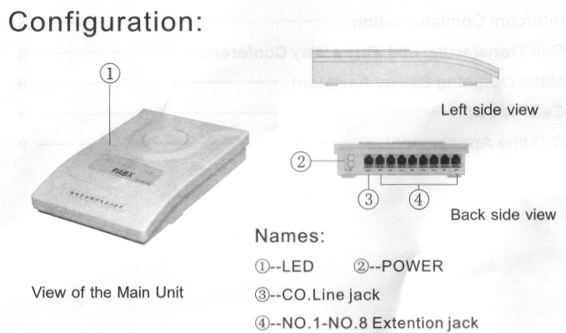
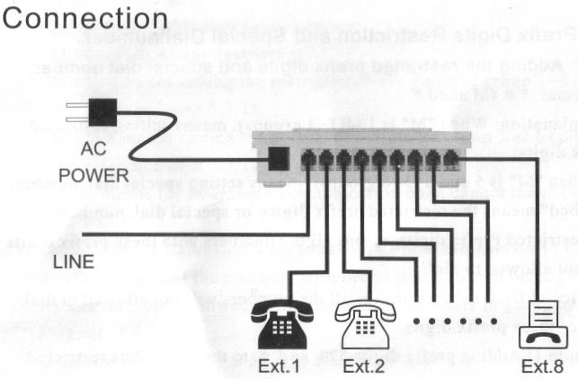
3. System Programming
3.1 Precaution
3.1.1 All the programming should be operated on No. 1 Extension; the Extension must be Double Tone mode.
3.1.2 Press "*#" to start programming, and end with "#".You could press directly to continue programming if any errors, you don't need to hang up. 3.1.3 After complete the programming, a long Beep "Du"indicates that the setting is done correctly, if instead of an array of short chirps is heard, that would indicate an error occurred.
3.1.4 The jack number is the Extension number.
1>Input * # 4 3 573# ;
2>Continue to input * # 4 3 8 # after hear "Du", and then hang up Example 2: Adding prefix digits 800 and 200 to the group 5 as special dialing number;
1>Input * # 45 800# ;
2>Continue to input * # 4 5 200# after hear "Du", and then hang up. Note:
1>Maximum has Four Prefix digits can be set, and end with # ; 2>Maximum has Twenty Sets Prefix digits can be set for each Group (1-4 Group);
3>Maximum Ten Sets Prefix digits can be set for each Group (5 -6 Group),
3.2 Ringing Extension Assignment Format: * # 1 abcdefgh #
Explanation: "abcdefgh" means the Extension number;
Example: Assign Extension 3 and 8 will ring when there has an incoming call is received:
1>Input *# 1 345678 # 2>Hang up after hear Du ;
3.3 Prefix Digits Restriction and Special Dial number. 3.3.1 Adding the restricted prefix digits and special dial number. Format: * # 4M abcd #
Explanation: When "M" is 1-4(1-4 groups), means setting restricted prefix digits;
When "M" is 5 and 6 (5-6 groups), means setting special dial number; "abcd" means the restricted prefix digits or special dial numbers. Restricted Prefix digits means all the numbers with these prefix digits will not allowed to dial;
Special Dial number means all the numbers will not allowed to dial besides these prefix digits.
Example 1: Adding prefix digits 573 and 8 to the group 3 as restricted dial number;
4
3.3.2 Clear Prefix Digits Format: * # 4 M #
Explanation; Suggest use this format to clear the previous setting before you want to set or change any prefix digits.
3.4 Outward Calling Class Assignment
3.4.1 Assign Outward Calling Class for Certain Extension Format: *#5 a M #
Explanation: "a" is Extension number; M =0 means no any restriction;
M =1 ~4 means setting the restricted prefix digits of group 1-4 (please reference item 3.3.1);
M =5-6 means setting the special dial digits of group 5 or 6 (please reference item 3.3.1)
M =7 means for Intercom Communication only, cannot make outgoing call.
Example: Assign Extension 6 for Intercom Communication only; Extension 3 not allowed to dial the numbers with prefix digits, which belong to group 3; Extension 8 only allowed to dial the special numbers in group 6.
1>Input * # 5 6 7 #
2>Continue to input * # 5 3 3 # after hear "Du" ;
3>Continue to input * # 5 8 6 # after hear "Du", and then hang up; 5
3.4.2 Assign Outward Calling Class for All Extensions Format: * # 5 0 M #
Explanation: Here M stands the same meaning as above. Use this format to assign outward calling class for all Extensions.
3.5 Call Duration Restricted
3.5.1 Assign Call Duration for Certain Extension Format: * # 3 a MN #
Explanation: "a" is the Extension number; "MN" is the call duration, from 1 minute ~60 minutes
Example: Assign five minutes as the call duration for Extension 3. 1>Input * # 3 3 5 # , and then hang up after hear "Du" ;
Thus, after five minutes, the line will be disconnected automatically while Extension 3 is talking with C.O line.
Note:
1>The actual call duration has about 20 seconds discrepancy from the duration what you have been set, in order to counteract your dialing time; 2>Call Duration maximum is 60 minutes.
3>There is no any restriction for Intercom communication and received incoming call.
3.6 Caller ID Assignment Format: * # 8 1 n #
Explanation: n =0 means without triggered n =1 means triggered
The most of telephone sets can support Caller ID even without ringing triggered, but there have some telephone sets cannot support Caller ID if without ringing triggered. The default mode of this model is without triggered. If the Caller ID is un-normal, you could set the unit is under triggered mode, but it would be cause some false ringing due to interference.
3.7 Restore the Default mode Format: * # 6 000 #
Explanation: In the case of forgetting of what you programmed, or you want to re-program the system, you could use this format to restore to default mode, and then program as per your needs.
The Default Setting
3.5.2 Assign Call Duration for All Extensions Format: * # 3 0 MN #
Explanation: "MN" is the call duration rang of time is from 1 minute to 60 minutes.
3.5.3 Clear the Call Duration for Certain Extension Format: * # 3 a #
Explanation: "a" is the Extension number
After clear the Call Duration restriction, you can talk freely without any duration restriction.
Ringing Extension ------------ 1 to 8 Extension Class --------------- 0 Restricted Prefix Digits------- No Special Dialing Number------ No Call Duration Restriction----- No Caller ID------------------------ Without triggered
4. Operating Instruction:
4.1 Answer the Call:
The ringing Extensions will ring when there has a incoming call is received, pick up the handset to answer the call directly.
4.5 Make Outgoing Call by Assistant Format: # * + Extension number
Explanation: The assistant can help to make outgoing call, and then transfer the call to another Extension by inputting this format.
4.2 Outward Calling:
Please input the C.O line number after you hear the external dialing tone. If the C.O line is busy, you will hear the internal dialing tone, and allow you to make internal call by inputting th a (a is the extension number.)
4.3 Intercom Communication
Pick up the handset, input * after you hear the external dialing tone, and
input the Extension number when you hear the internal dialing tone; the
Extension will enter internal line if the C.O line is busy, and input the * a (a is the _{e}xtension number.)
4.4 Call Transferring and Three Way Conference Please input * + Extension number to transfer the call.
Example, when Extension A is received an incoming call, and A is transferring the call to Extension B, there would be have following four kinds case:
1>A doesn't hang up, B pick up;
B picks up the handset, but A doesn't hang up, so they will connect with C.O to build a three way conference; Any one of them between A and B hang up, will still allow one side is connecting with C.O line.
2>A doesn't hang up, B doesn't answer the call within 30 seconds;
A will restore the communication with C.O line if B doesn't answer the call after 30 seconds.
3>A hang up, B pick up
B picks up the handset to answer the call
4>A hang up, B doesn't answer after 30 seconds;
If A is free after 30 seconds, it will ring again, allowed A picks up the handset to answer the call within 25 seconds; if A is busy, the line will be disconnected.
4.6 Call Pick Up Format: 0 # Explanation: Allow you to answer the call on silent Extension
4.7 C.O line Appointment Format: 9 #
Explanation: You will hear internal dialing tone if the C.O line is busy, you could input 9 #, and then hang up after hear "Du". As soon as there has free line, your Extension will have a ring as indication.
After you input 9 #, the Extension that is talking with C.O line can hear "Du-Du-Du" to indicate him / her that other people wants to make outgoing call.

